**Module 19**

Question 🡪

*Explain the detailed steps to train a GAN model. Also explain on the architecture of SRGAN.*

**Training a GAN: -**

* Define a Problem.
* Define architecture of GAN (MLP/NN).
* Train the discriminator to distinguish “real” vs “fake” data.
* Train the generator.
* Repeat above two steps N times.
* Once the training is completed, synthesize data from generator.

**Architecture:**

Similar to GAN architectures, the Super Resolution GAN also contains two parts Generator and Discriminator where generator produces some data based on the probability distribution and discriminator tries to guess weather data coming from input dataset or generator.  Generator than tries to optimize the generated data so that it can fool the discriminator. Below are the generator and discriminator architectural details:

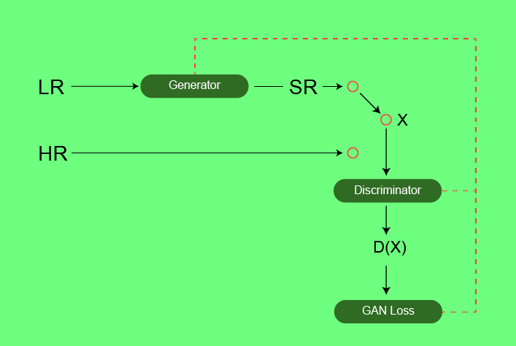

**Generator Architecture:**

The generator architecture contains residual network instead of deep convolution networks because residual networks are easy to train and allows them to be substantially deeper in order to generate better results. This is because the residual network used a type of connections called skip connections.

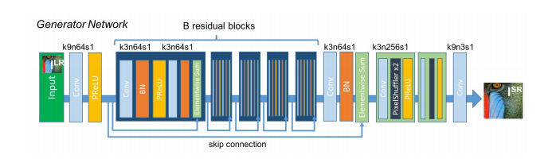

**Discriminator Architecture:**

The task of the discriminator is to discriminate between real HR images and generated SR images.   The discriminator architecture used in this paper is similar to DC- GAN architecture with LeakyReLU as activation. The network contains eight convolutional layers with of 3×3 filter kernels, increasing by a factor of 2 from 64 to 512 kernels. Strided convolutions are used to reduce the image resolution each time the number of features is doubled. The resulting 512 feature maps are followed by two dense layers and a leakyReLU applied between and a final sigmoid activation function to obtain a probability for sample classification.

